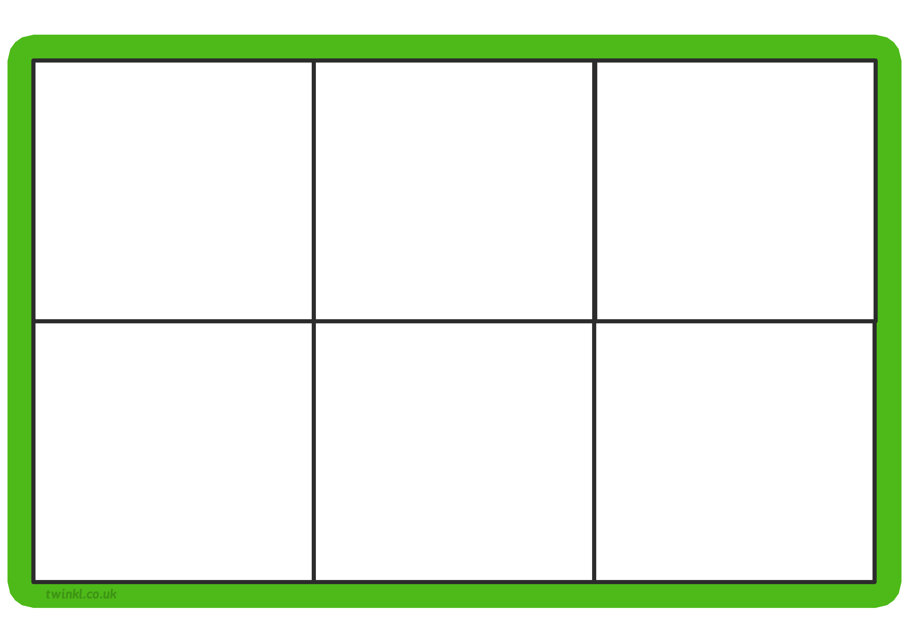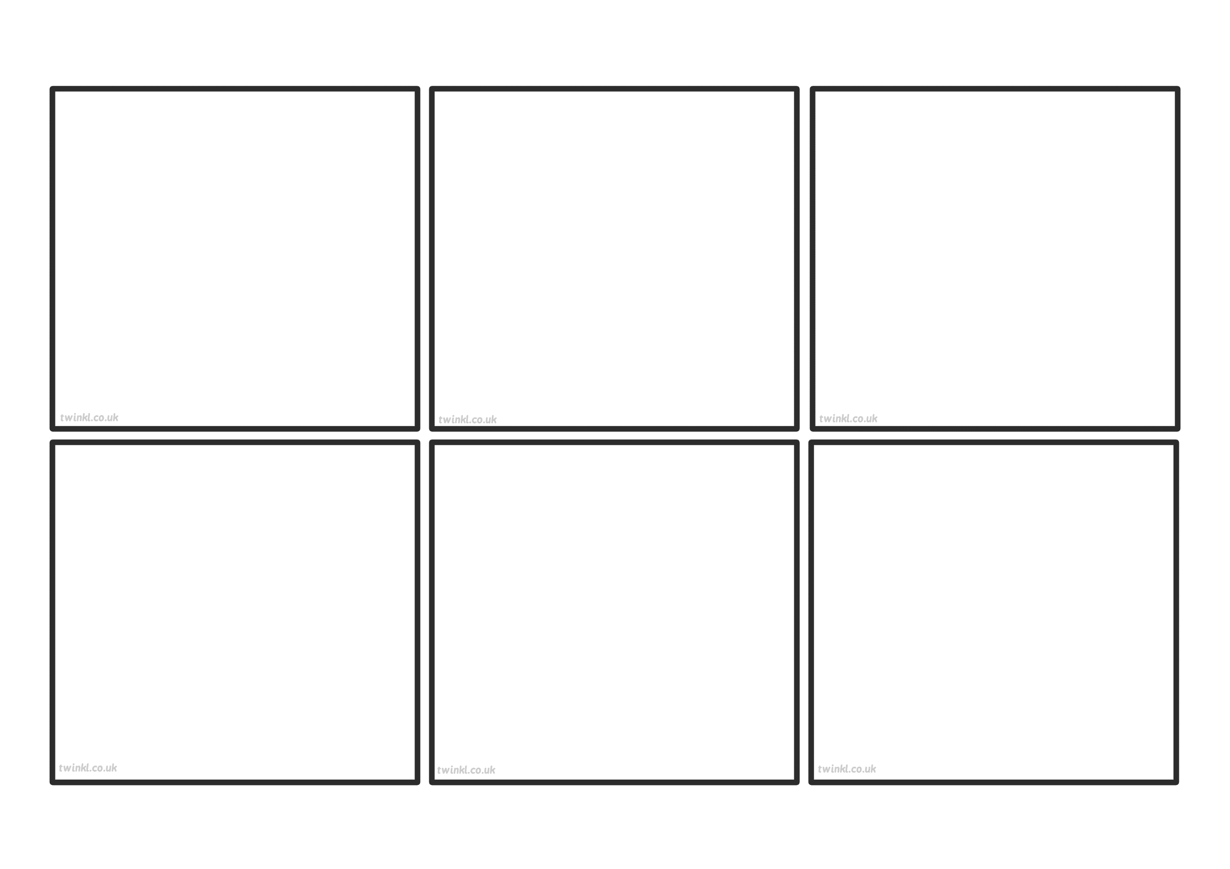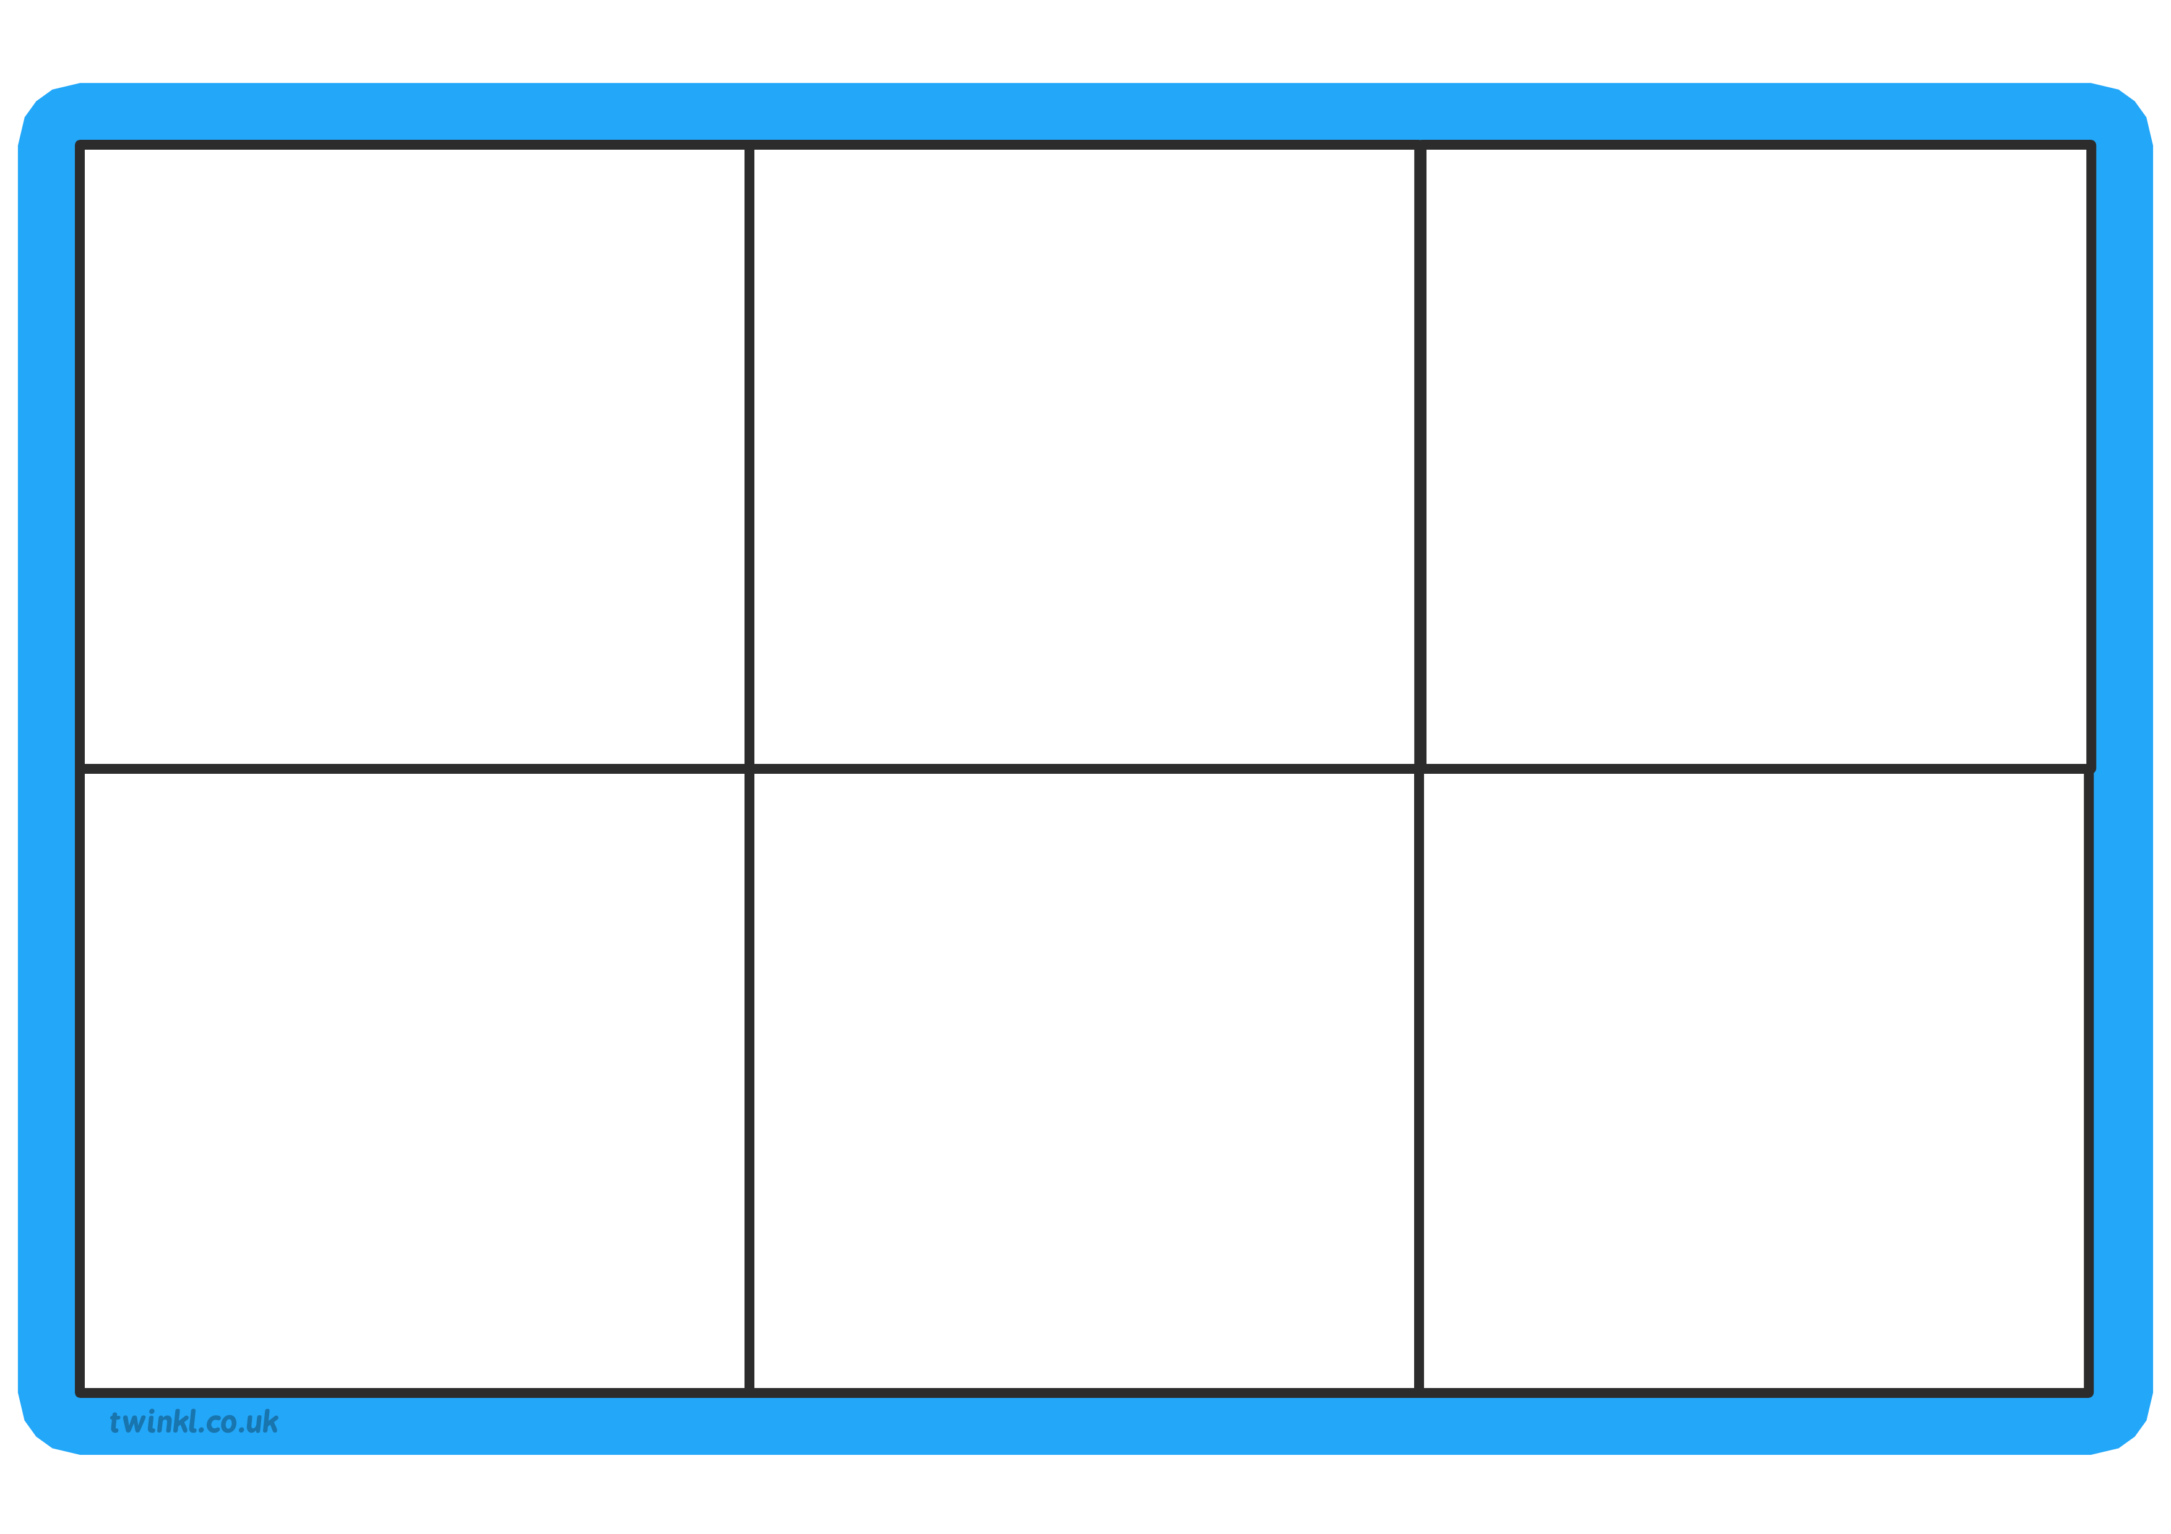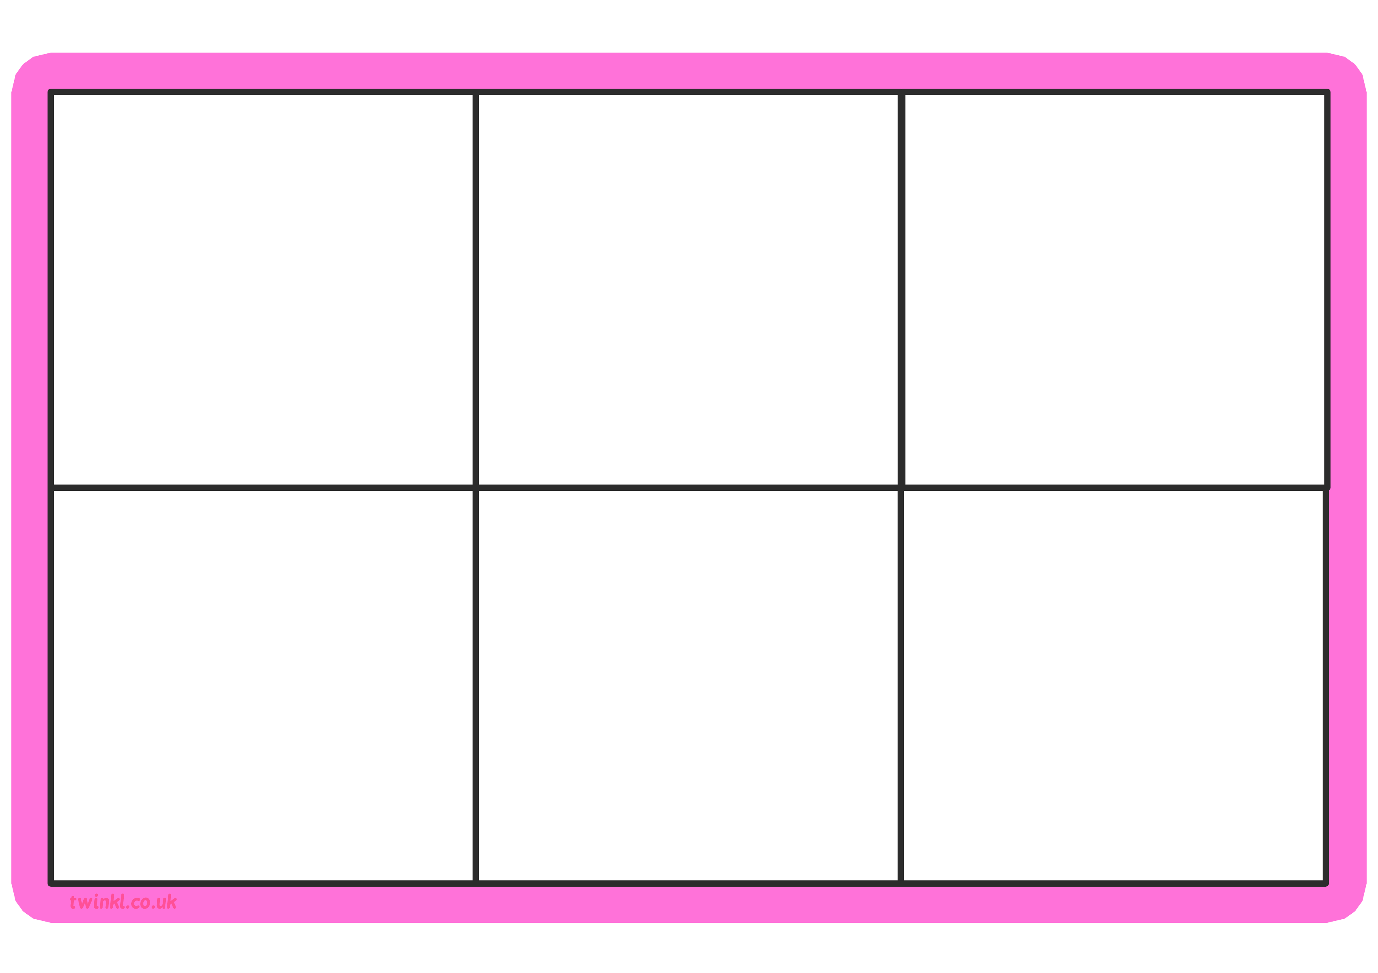

no

put

I

the

to

my

no

put

I

the

to

my

I

no

the

of

you

to

to

you

of

the

no

I

no

to

put

me

the

I

I

me

put

to

no

the