Elm Class Easter Activity Ideas

Happy Easter Elm Class!

I hope that you are still enjoying time with your families at home.

Here are some ideas to help keep you busy over the Easter Holidays.

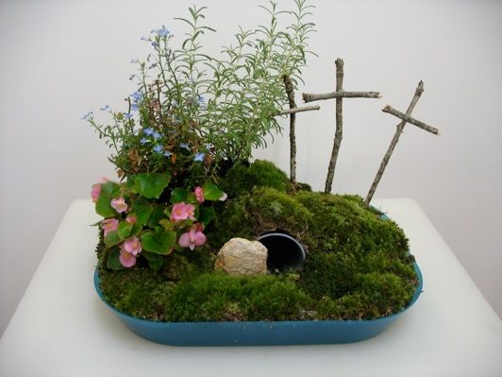Design and made an Easter Garden.

This week’s #LiveLent challenge focus is: Humans and other animals. Can you care for the animals that share your home this week? There are also daily activities inside your Live Lent booklet!

If you do manage to go for a walk during the coming days, whilst keeping social distance, perhaps you could look out for the rainbows in the window and see how many you can count.

Can you create your own rainbow poster with a message of compassion and hope?

Play board games, puzzle or card games with your family. Why not set up a family competition with a leader board and homemade trophy?

Make Easter Eggs from card or paper and create your own Easter Egg hunt around the house or garden.

The Young Vets Club are holding a competition to design a new animal. <https://www.youngvetsclub.com/daily-fun>

The Wildlife Trust have lots of great ideas for things to make this Easter including make your own glow worm and an edible pond!

<https://www.wildlifetrusts.org/looking-after-yourself-and-nature>

Rhythms of play also have lots of ideas to keep you active.

<https://rhythmsofplay.com/forest-school-outdoor-learning-and-nature-activities-for-kids/>

Can you write an Easter acrostic poem?

Make Easter Cards and post them to family members or deliver them to elderly neighbours.

Take part in the Big Little Tent Festival. Get into the festival spirit by pitching a tent in the garden or build a den in your house. Download the Festival activity pack for event wristbands, bunting and lots of great activities. <https://www.caravanclub.co.uk/whats-on/big-little-tent-festival/>

Most importantly, spend quality time together as a family. Please stay and home and stay safe. I am thinking of you all and miss you lots. I look forward to seeing what you get up to.

Kindest regards,

Mrs Corbett.