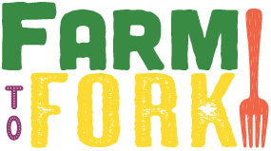 ***Farm***

***ELM CLASS***

***Curriculum Map***

***to Fork***

Fabulous Finish

To finish off the theme, we will visit a Farm Park to help look after animals and learn about farm life. We will take part in a learning showcase to celebrate all of our fantastic work.

Sparkling Starter

We will sample food from farms from around the world, searching for them on world maps. We will make bird feeders and sun catchers. We will work together to create a collage.

Brilliant Beginning

The children were asked to think about their favourite food and where it comes from. Create a piece of art work of an animal or farm machinery to add to our display.

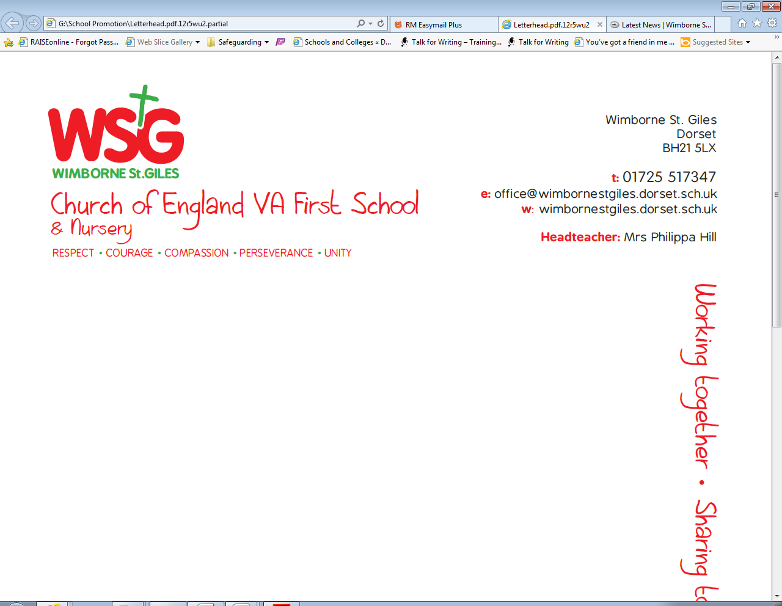

|  |  |  |  |  |
| --- | --- | --- | --- | --- |
| *Respect* | *Compassion* | *Courage* | *Perseverance* | *Unity* |
|  | Fairtrade -make a difference to the lives of the people who grow things we love. |  | We will learn about the perseverance needed to develop and sustain an allotment. | Children will work together to create a school allotment. |

The topic will develop the children’s geographical skills and their understanding of their role as global citizens. It will inspire them to think about the food on their plates and the role of farming.

As we are aiming for our Green Eco Schools status, the topic will address one of the nine key areas. We will consider our use of energy and how we can lower this to reduce our impact on climate change.

**Why?**

**Eco schools**

What do farmers do? Who can be a farmer?

Are all farms the same?

Where does the food in my lunchbox come from?



**Global**

**Learning**

As Global Citizens we will focus on social justice and equity.

Should animals have rights? Which ones?

What is the different between free-range and battery hens? Which would you rather be?

**Pupil led learning**

We will explore the work of Giuseppe Arcimboldo and create our own vegetable artwork. We will use objects to create prints. Using a combination of materials that are cut, torn and glued we will create farm inspired collages. We will sketch observational drawings, using lines of different sizes and thickness and showing pattern and texture by using different lines.

• Colour (own work) neatly following the lines.

We will continue to use outdoor learning in order to enrich the curriculum and to give children practical problem solving opportunities.

**Art and**

**Design**

**Outdoor Learning**

As design technologists we will cut, peel and grate ingredients safely and hygienically to make vegetable soup. We will weigh our ingredients carefully using electronic scales.

We will design and construct our own scarecrows using a range of joining techniques. We will dress them by cutting textiles using templates and joining by using running stitches.

**Design**

**Technology**

We will be using some of the advanced features of applications and devices in order to communicate ideas, work or messages professionally.

**Computing**



We will recap the wonderful world and the story of creation. We will then learn about God. How do Christians show their belief in God? We will think, talk and ask questions about what God is like. We will explore the story of Jonah.

We will play competitive games, modified where appropriate and apply basic principles suitable for attacking and defending. We will continue to develop our practical skills to participate, compete and lead a healthy lifestyle.

As geographers, we will use simple fieldwork to study the surrounding environment.

We will identify seasonal and daily weather patterns in the United Kingdom.

We will continue to use the Talk For Writing Approach to fiction and non-fiction writing. As writers we will be exploring the genres of poetry and non-chronological reports. In our fiction writing we will be exploring books by the same author and start to write stories with imaginary settings.

We will continue to follow the Read Write Inc. scheme to develop our basic reading, writing and phonics skills. This will include rereading stories to develop our understanding and fluency and applying decoding skills to common words to increase our speed of reading common words quickly.

As Scientists, we will investigate living things, exploring and comparing the differences between things that are living, that are dead and that have never been alive. Identify and name a variety of common plants, including garden plants, wild plants and trees and those classified as deciduous and evergreen. We will identify and describe the basic structure of a variety of common flowering plants, including roots, stem/trunk, leaves and flowers.

We will work scientifically, performing tests, asking questions and gathering and recording data to help answer our questions.

**Science**

**P.E.**

**History**

As historians, we will begin explore the history of farming, placing artefacts in order on a time line. We will look at changes that have occurred in our recent history.

**Geography**

**Maths**

We will be using the Maths No Problem resources in order to develop our children’s depth of mathematical understanding. As mathematicians we will be developing our knowledge of shape and fractions. We will continue to carry out calculations using addition, subtraction, division and multiplication. We will learn how to use models to help us develop efficient calculation methods and strategies and we will use these skills to solve increasingly complex problems.

**English**

As Musicians we will choose, order, combine and control sounds to create an effect using musical instruments and digital technologies.

**R.E.**

**Music**