***Going***

***ELM CLASS***

***Curriculum Map***

***Global!***

Sparkling Starter

We will start the theme with a Global Day. Elm Class will focus on Brazil and will take part in a dance workshop, make traditional Brazilian food and learn some Portuguese!

Fabulous Finish

To finish off the theme, we will take part in a learning showcase to celebrate all of our fantastic work.

Brilliant Beginning

The children were asked to find out about where they come from and which cities and countries they have visited both in the UK and around the world. They plotted the locations on a world map.

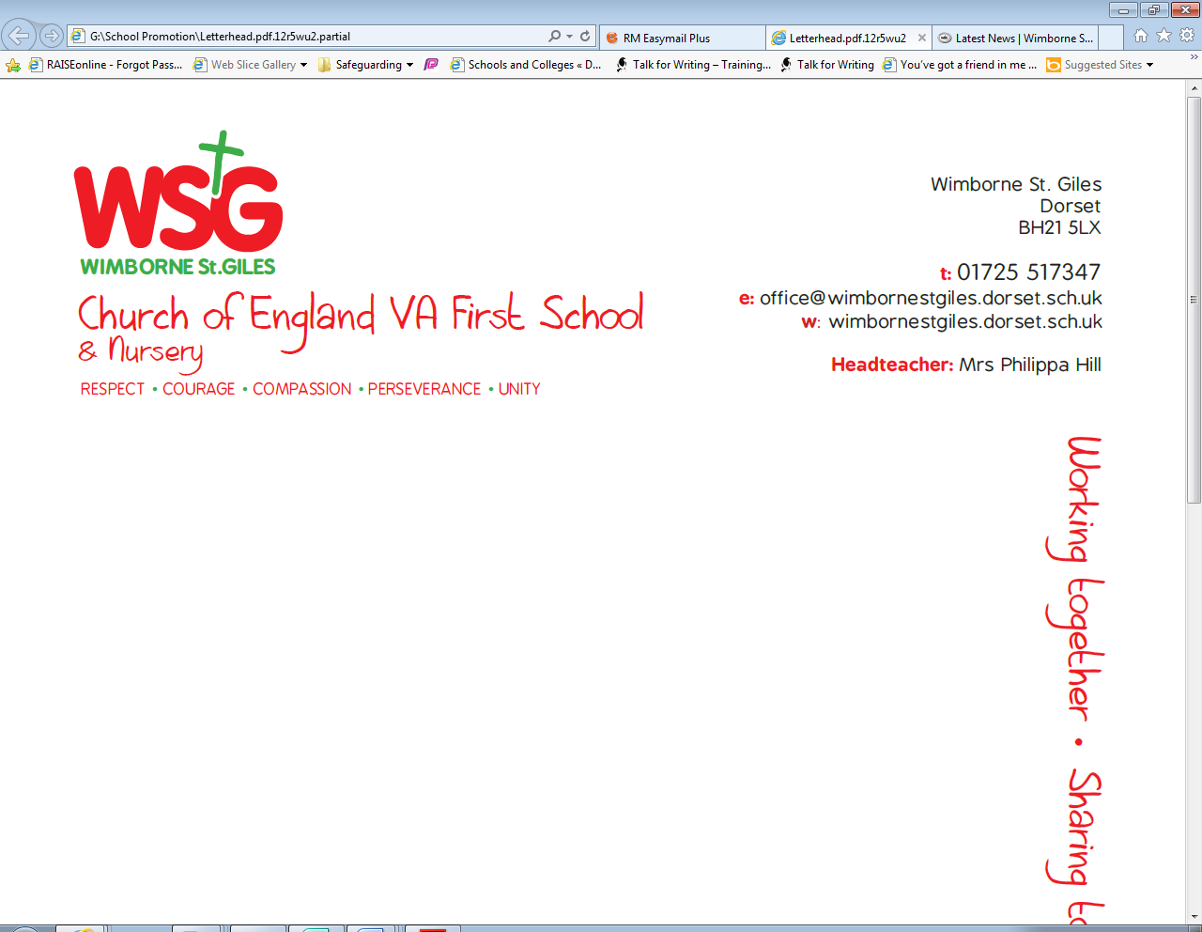

|  |  |  |  |  |
| --- | --- | --- | --- | --- |
| *Respect* | *Compassion* | *Courage* | *Perseverance* | *Unity* |
| Respect and care for our planet - Sustainability and deforestation | Fairtrade -make a difference to the lives of the people who grow things we love. |  |  | Carnival Time! Neighbours work together to create and accompany floats which parade the street. |

The topic will develop the children’s geographical skills and their understanding of their role as global citizens. It will inspire them to think about different environments in the world and our impact on them.

As we are aiming for our Green Eco Schools status, the topic will address one of the nine key areas. We will consider our use of energy and how we can lower this to reduce our impact on climate change.

**Why?**

**Eco schools**

Where is Brazil?

What would life be like there? How is it the same? How is it different?

The Brazilian Rainforest – what’s it like? What lives there?



**Rights Respecting Schools**

As a Rights Respecting School we will consider the following UNICEF Rights of the Child in this topic;

**Article 29: Your education should help you use and develop your talents and abilities. It should also help you learn to live peacefully, protect the environment and respect other people.**

**Pupil led learning**

We will explore the work of Henri Rousseau and create our own jungle landscape pictures – adding tints and tones to our work. We will create colour wheels by mixing primary colours to make secondary colours.

We will use overlapping shapes to mimic print from environment.

We will continue to use outdoor learning in order to enrich the curriculum and to give children practical problem solving opportunities.

**Art and**

**Design**

**Outdoor Learning**

As Design Technologists we will design a tree climbing device using levers, wheels and winding mechanisms.

We will assemble ingredients and measure and weigh them to make some traditional Brazilian sweet treats.

**Design**

**Technology**

We will be using some of the advanced features of applications and devices in order to communicate ideas, work or messages professionally.

**Computing**



As Scientists, we will observe and describe how seeds grow into mature plants and describe how they need water and light to grow. We will name and draw the basic parts of the human body and say which part is associated with each sense.

We will work scientifically, performing tests, asking questions and gathering and recording data to help answer our questions.

**Science**

**P.E.**

We will play competitive games, modified where appropriate and apply basic principles suitable for attacking and defending. We will link two or more actions to perform a sequence of Brazilian samba dance steps.

**History**

As historians we will begin to look at chronology and place significant dates in our lives on a time line. We will label our time lines with past, present, older and newer.

As Geographers, we will ask and answer questions about Brazil. We will identify seasonal and daily weather patterns in the UK and Brazil. We will name, locate and identify the 4 countries of the UK and their capital cities.

**Geography**

**Maths**

We will be using the Maths No Problem resources in order to develop our children depth of mathematical understanding. As mathematicians we will be developing our knowledge of time, money and fractions. We will continue to carry out calculations using addition, subtraction, division and multiplication. We will learn how to use models to help us develop efficient calculation methods and strategies and we will use these skills to solve increasingly complex problems.

**English**

As Musicians we will choose, order, combine and control sounds to create an effect using musical instruments and digital technologies.

We will study Judaism, exploring how important it is for Jewish people to do what God has asked of them. We will go on to learn about Islam and if completing Hajj make a person a better Muslim.

**R.E.**

**Music**

We will continue to use the Talk For Writing Approach to fiction and non-fiction writing. As writers we will be exploring the genres of Recount and Persuasion. In our fiction writing we will be exploring Adventure stories.

We will continue to follow the Read Write Inc. scheme to develop our basic reading, writing and phonics skills. This will include rereading stories to develop our understanding and fluency and applying decoding skills to common words to increase our speed of reading common words quickly.