**WALT:** use imaginative description

Write a sentence of three to describe the characters below:

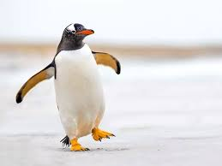

The penguin has _____________________ ,

______________________ and

______________________.

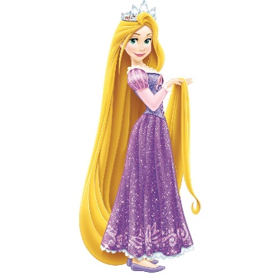

The princess has _____________________ ,

______________________ and

______________________.

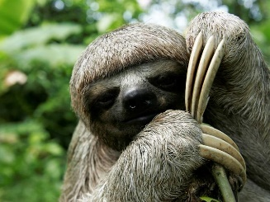

The sloth has _____________________ ,

______________________ and

______________________.

Now it’s your turn. Draw a picture and describe it using a sentence of three.