River DATA;Hundreds of rivers and their tributaries cross the European continent. Here we are highlighting those over 600 miles in length, and a few others of note.

DANUBE
Beginning in the Black Forest region of Germany, it flows across central Europe and the countries of Austria, Hungary, Croatia and Yugoslavia. It then forms the border between Romania and Bulgaria, turning north across Romania to eventually end in the Black Sea.
It's (1,771 miles) (2,850 km) in length, and one of the most significant commercial waterways on the continent.

DNIEPER
Rising in the southwestern part of the Russian Federation, it flows generally south through Belarus, then southeast through Ukraine, ending in the Black Sea. Overall it's (1,420 miles) (2,285 km) in length.

DON
Beginning it the southwestern Russian Federation, to the south of Moscow, it flows southeasterly towards the Volga, then turns abruptly west, ending in the Sea of Azov. Overall it's (1,224 miles) (1,969 km) in length.

ELBE
Rising in the Czech Republic, the Elbe River then flows north through Germany, ending in the North Sea near Cuxhaven. It's (724 miles) (1,165 km) in length.

LOIRE
Recognized as the longest river in France, the navigable Loire begins in the foothills of the Massif Central, then flows north and west across the heartland of France, finally ending in the Bay of Biscay. It's (634 miles) (1,020 km) in length.

ODER
Rising in the rugged mountains of the eastern Czech Republic, it flows west and north through south-central Poland, eventually emptying into the Baltic Sea. It's (567 miles) (912 km) in length.

PO
Italy's longest river begins in the upper reaches of the Alps, flowing west to east across northern Italy, ending in the Adriatic Sea. It's (405 miles) (652 km) in length.

RHINE
Forming in the mountains of southeastern Switzerland, this legendary river flows west, forming Switzerland's northeastern border with Germany, then runs directly north through western Germany forming part of that country's border with France, then finally dissecting the Netherlands and ending in the North Sea.
Numerous tributaries and branches run in all directions, and in overall length is (820 miles) (1,319 km).

RHONE
Begin high in the Swiss Alps, this fast moving river flows into the eastern end of Lake Geneva, then south through south-eastern France, emptying into the Mediterranean Sea.
Small branches run in all directions, and in overall length, it's (300 miles) (485 km).

SHANNON
Rising in northwestern Ireland, it flows south through a series of lakes, then turns west to eventually empty into the Atlantic Ocean. It's 230 miles (370 km) in length.

TAGUS
The Tagus River rises in the central highlands of Spain, flowing southwest across Portugal, then south to Lisbon and the Atlantic Ocean. It's 626 miles (1,007 km) in length.

Source : World Atlas

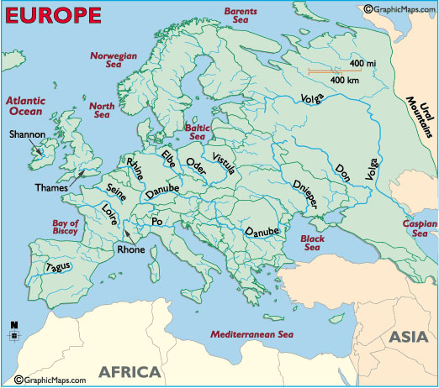
Europe River tours LTD
You work for the above company. Your job is to investigate a river in Europe for the potential for a river cruise holiday.
First; choose your river.
- Where is the river?
- Where does your river start (source) and end (mouth of river)?
- How long is it?
- What countries does it flow through?

Second; the Cruise.
5. Why would your customers choose your river cruise?
Physical Geography - What physical features would people see/feel? (E.g. mountains – river landscapes – farming – weather/climate)
Human Geography – what places would you visit on your cruise? (E.g. settlements – tourist attractions - museums – historical features).

Present your work as a leaflet or poster.
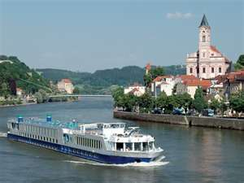
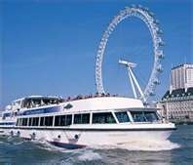
Rivers in Europe

