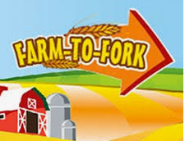***Farm***

***Oak Class***

***Curriculum Map***

***To Fork!***

Fabulous Finish

We will go on a school trip and visit a local farm park.

We will have a learning showcase to display their learning from across the term.

**Sparkling Starter**

We will be doing food tasting from foods from around the world. We will design and start to create an allotment area and we will also design and make bird feeders/wind chimes/scarecrows. In class we will plant an indoor herb garden.

Brilliant Beginning

The children were asked to find out about farming in the local area .

Create a piece of artwork of an animal or farm machinery to add to our display for next term.

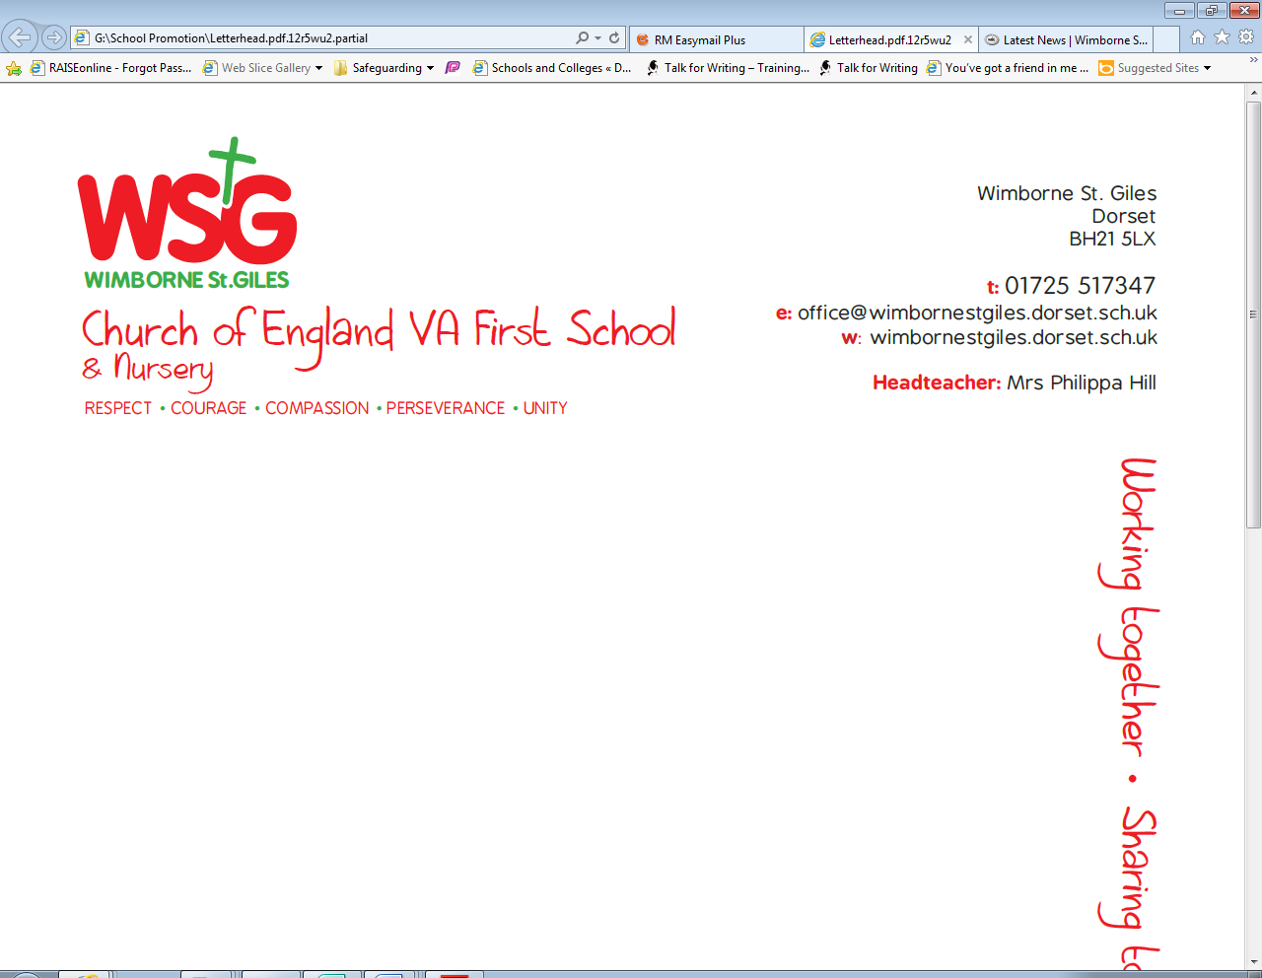

|  |  |  |  |  |
| --- | --- | --- | --- | --- |
| *Respect* | *Compassion* | *Courage* | *Perseverance* | *Unity* |
| We will learn about hope and aspiration of community and living well together. We will value the environment and discuss sustainable development. | Fairtrade-  The children will make a difference to the lives of the people who grow the things we love. | We will learn about democracy and the rule of law and the belief about how people can bring about change. | We will learn about working hard and perseverance it takes to sustain a farm and develop our own allotment over the course of the year. | The children will work together to create a school allotment. |

This topic will develop the children’s geographical skills and their understanding of their role as global citizens. It will inspire them to think about the journey and process of the food found on their plate and the role of farming across the world.

As we are aiming for our Green Eco Schools status, the topic will address one of the nine key areas. We will consider our use of energy and how we can lower this to reduce our impact on climate change.

**Why?**

**Eco schools**



**Global**

**Learning**

We will be learning about Social Justice and Equity -

What is Fair trade?

Are the rules for trade all the same in every country?

Who represents the rights of the animals?

Do we treat animals fairly?

Where are our local farms?

What food is associated with your locality?

What are the differences in local faming and farming around the world?

How far does your favourite meal travel?

What is the red tractor mark?

What is the difference between Fairtrade bananas and non fairtrade bananas?

**Pupil led learning**

We will visit our local area and sketch animals, buildings, horizons etc. Use different grades of pencils and charcoals to recreate patterns seen on the farm. Review the different effects. Make observational drawings of fruit and vegetables using charcoals, pencils, pastels and chalks. Make a layered picture of the farm starting with the basic layout of buildings and fields in paint. Use pastels and felt-tips to add detils to buildings, fences and hedgerows. Add collage animals and crops

Guisuippi inspired art .

**Art and**

**Design**

We will be developing our Forest Area to enhance the habitat for local wildlife and develop our local flora and fauna.

We will design and create a whole school allotment.

**Outdoor Learning**

We will be learning about the influence of persuasive technology over intentional technology. We will be using beebots, iPads and laptops to do programming and coding .ScratcJunior App.

**Computing**

We will be learning abo what makes a healthy meal and creating our own.

**Design**

**Technology**



We are using Understanding Christianity to develop our children’s understanding of religion. We will start by recapping what makes our Wonderful World and The Creation Story. Then move onto studying ‘The people of God’ and make links between the story of Noah and Abraham and how we live in school and the wider world.

As Musicians we will learn about pulse and rhythm and pitch and tempo. We will work in small groups to create pieces of music.

**Music**

**Science**

**Geography**

During this unit we will be looking at how food has travelled to connect the world in more ways than ever before. We will also look at what we buy and what we consume and how this has a profound impact on the lives and societies of people around the world.

We will continue to use the Talk For Writing Approach to fiction and non-fiction writing. As writers we will be exploring the genres of Persuasion to create our own persuasive texts about fairtrade and create and advert for our tractor designs.

We will continue to read our class book Harry Potter and we will also study Stories by Dick King Smith and Fantastic Mr Fox by Roald Dahl.

We will continue to follow the Read Write Inc. scheme to develop our basic reading, writing and phonics skills.

**R.E.**

We will continue to play competitive games, modified where appropriate and apply basic principles suitable for attacking and defending. We will start practising netball for a netball festival next term.

**English**

As historians we will be investigating how farming and transport has changed over time.

We will continue to develop our investigative skills through many of our science lessons and will take part in experiments, using scientific vocabulary and learning to make our own hypothesis, write our own methods and conclusions.

As Scientists, we will be learning about plants, healthy living, the human body and about foodchains and foodwebs.

**P.E.**

**History**

We will be using the Maths No Problem resources in order to develop our children depth of mathematical understanding. We will continue to develop the 4 operations and apply them into different problem solving contexts. We will be focussing on multiplication and division next term.

**Maths**