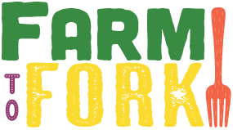

***Ash Class***

***Curriculum Overview***

Brilliant Beginning

The children will be asked to create their own farm animals to bring in for classrooms displays. Children will be asked to think about their favourite food and begin to think/research about where it’s come from.

Fabulous Finish

The children will display their learning at our Learning Showcase at the end of the spring term. We will visit a farm park to look at animals and farm life.

Sparkling Starter

The whole school will join together for an introduction to our topic. We will sample food from farms around the world. We will begin to design a school allotment and make bird feeders and wind chimes.

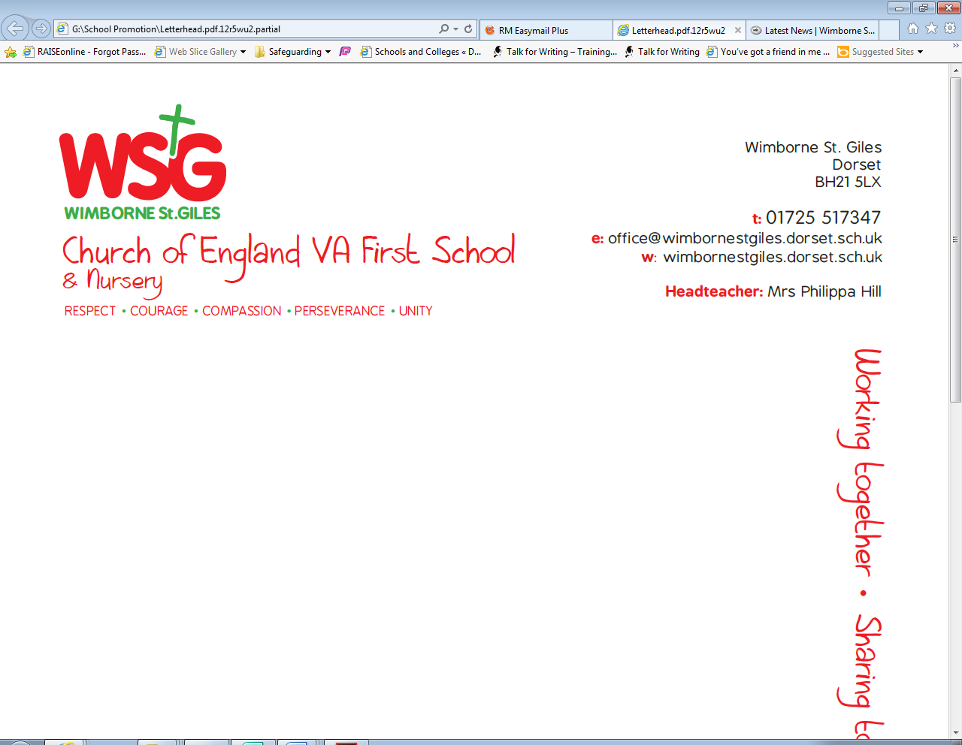

|  |  |  |  |  |
| --- | --- | --- | --- | --- |
| *Respect* | *Compassion* | *Courage* | *Perseverance* | *Unity* |
|  | Fair trade- Make a difference to the lives of people who grow the things we love |  | Using the story ‘ The Little Red Hen’ the children will begin to understand how the Hen had to show persevere to make food | Children will work together to create a school allotment |

The topic will develop the children’s geographical skills and their understanding of where their food comes from. It will inspire them to think about different environments and what they can do to sustain a healthy lifestyle.

As we are aiming for our Green Eco Schools status, the topic will address one of the nine key areas. We will consider our use of energy and how we can lower this to reduce our impact on climate change.

**Why?**

**Eco schools**



**Global Learning**

Should animals have rights?

Why are hens kept in different ways?

Would you rather have a free range or battery hen?

Looking at different farms around the world- comparing their similarities and differences.

Demonstrating a healthy lifestyle

**Pupil led learning**

Physical Development

In P.E sessions, the children will begin with basic ball and team work skills. Children will continue to build their arm and hand muscles and form letters correctly- beginning to use relative sizing of letters. Through the topic, children will show an understanding of healthy eating, contributing to good health.

Personal, Social and Emotional Development

This term the children will talk about their and other’s behaviour and it consequence- using the school rules ‘ready, respectful and safe.’ They will be encouraged to take into account what other’s ideas about how to organise an activity.

.

Communication and Language

The children will be encouraged to accurately respond with relevant comments after listening to stories. They will begin to answer ‘how’ and ‘why’ questions and will be encouraged to use past, present and future accurately.

Use past present and future tenses accurately

**Expressive Art and Design**

The children will use colour for a particular purpose when drawing and using different dried food will be encouraged to experiment with texture

**Outdoor Learning**

Through forest afternoons, children will create and tend to a school allotment, making decisions about the type of foods they grow.

**Understanding the World**

Through the farm to fork topic, children will compare farms in the UK and other countries to develop an understanding of different communities.

**Mathematics**

In practical ways, children will add and subtract two single digit numbers to find an answer.

Through the story of ‘The little red hen’, children will begin to use everyday language related to size and weight of different fruit and vegetables.

Literacy

Through Talk 4 Writing, children will look at ’The little red hen’ and learn to retell this story, using a story map and actions. They will also build upon their narrative language, using small world resources to make up their own stories and use their phonic knowledge to begin to write their own stories.

The will begin the Read Write Inc. scheme to develop their basic reading, writing and phonics skills. This will include learning set 2 sounds and continue to blend them to read words and sentences. Children will be encouraged to continue to write sentences using their phonic knowledge.

