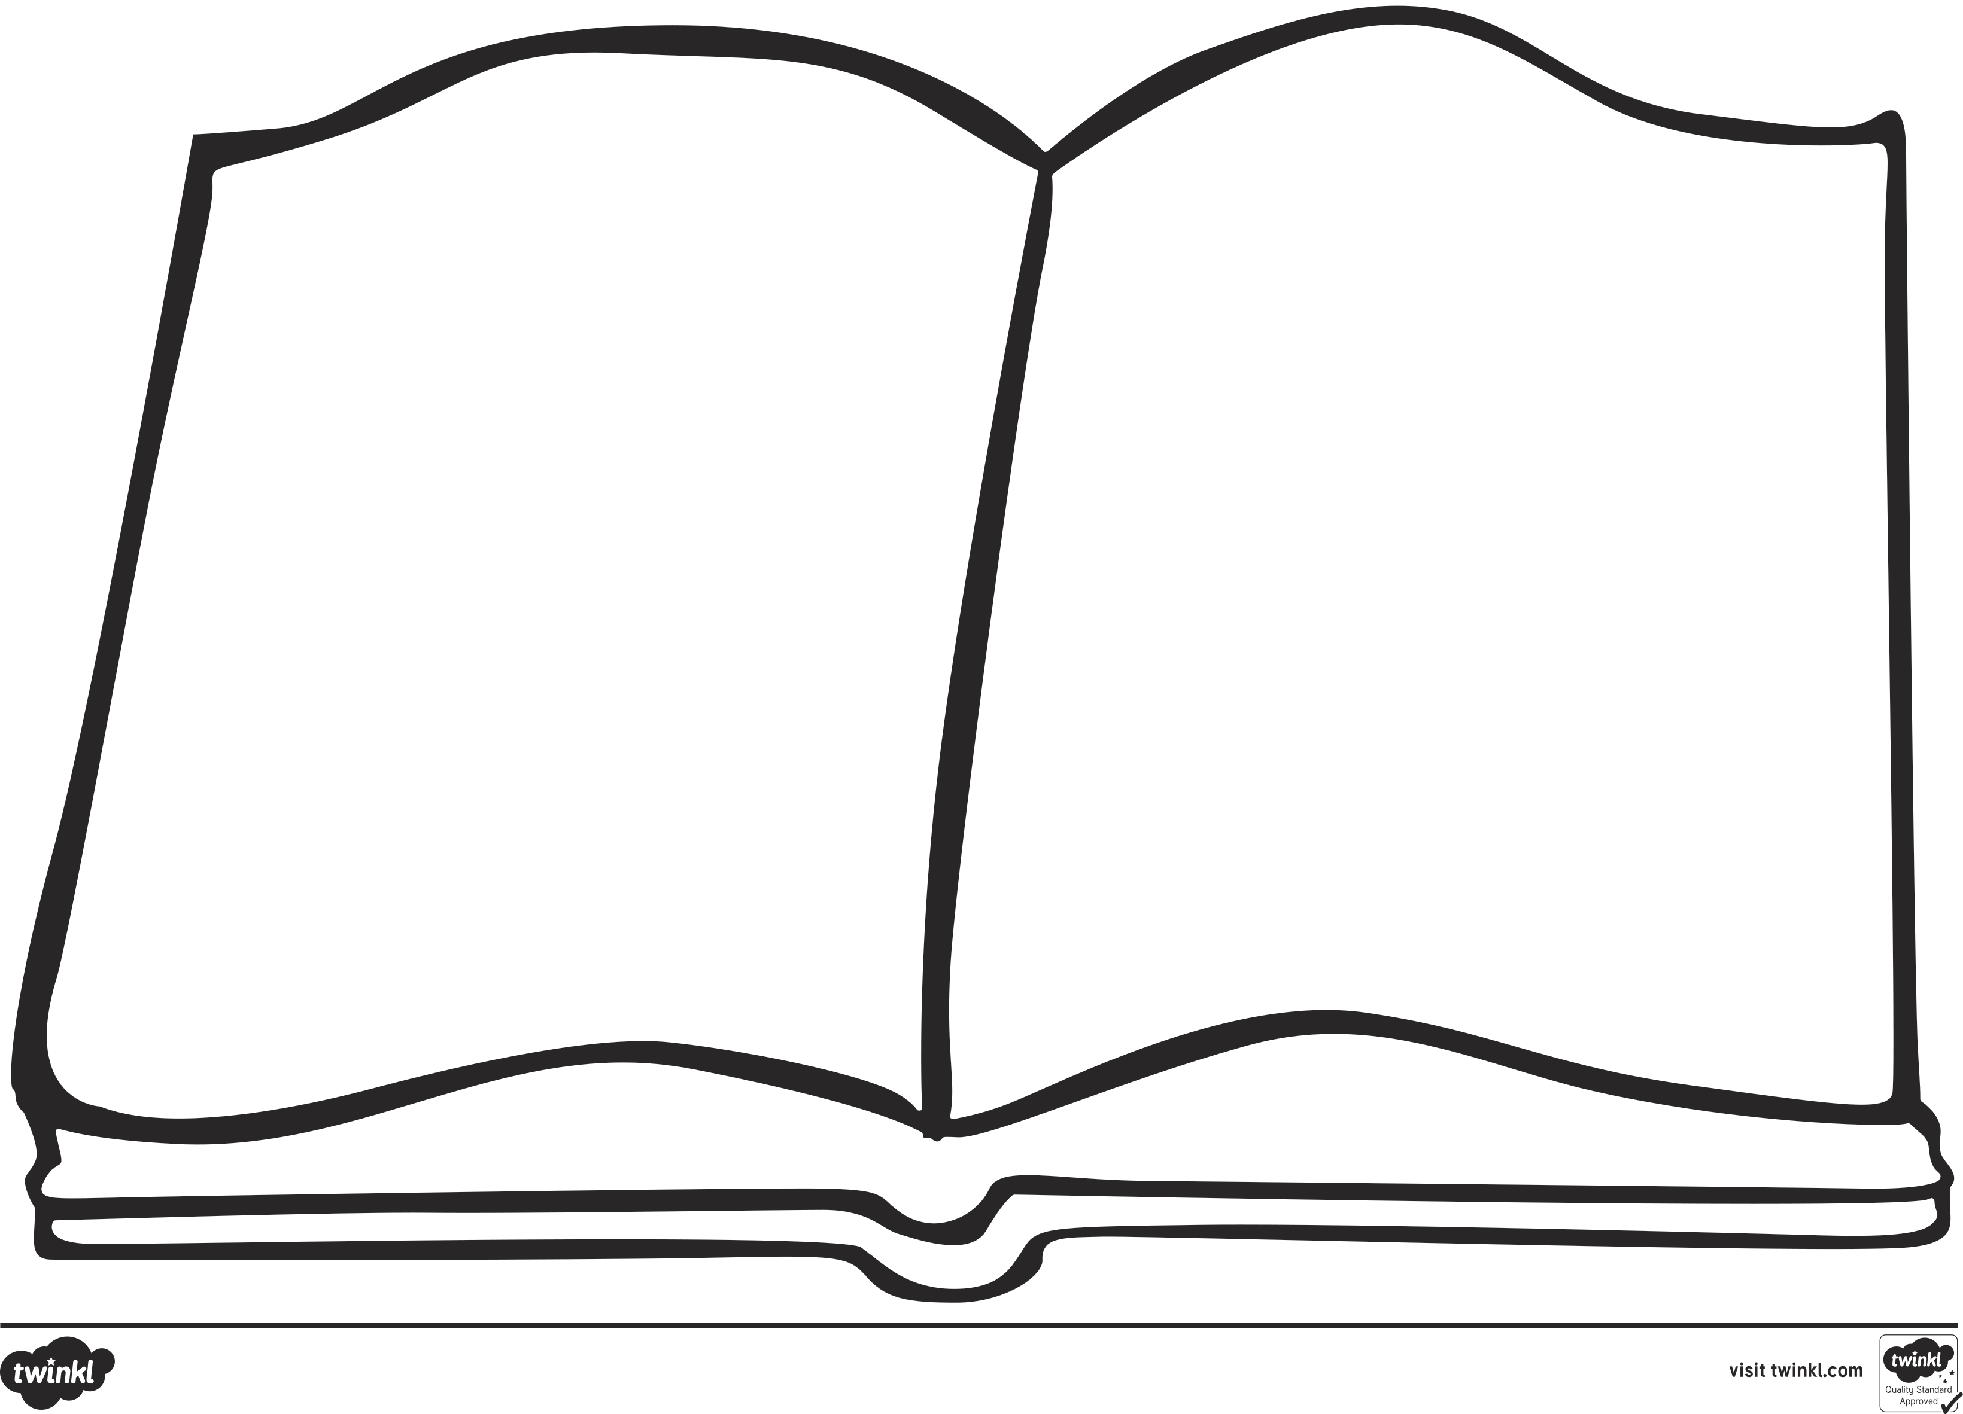
My favourite character
My favourite part of the story

