Please remember, this is only a guide to support you at home. Do what you can or try out your own ideas- whatever is easiest for you and your child. I love seeing all your posts on Tapestry and miss you all lots. Stay safe and don’t forget to get in touch if you need any support- ashclass@wimbornestgiles.dorset.sch.uk
Kindest Regards
Miss Deakin
W/C 15.06.2020: Learning Project - Space
Age Range: Ash
Physical Development
Gross Motor  - 9.00 am Joe Wicks  - Cosmic Yoga  - Daily mile or walking in your local area  - Give GoNoodle a try for fun movements and mindfulness | Fine Motor  Handwriting letters to practise:  h- Down the horses head to his hooves and over his back, flick  - Down the insects body, flick, dot for his head  j- Down the hisbody, curl and dot  m- Masie, mountain, mountain, flick  n- Down Nobby and over his net
Weekly Reading Tasks | Weekly Phonics Tasks
Monday- Visit Storytime from Space and let your child listen to the Story Time video of A Moon of My Own. | Monday- Daily phonics - Practice the sounds your child is working on the Ruth Miskin’s website at 10am- set 2 sounds  NB. If you feel your child is secure in all set 2 sounds, you may wish to start set 3 sounds at 10.30.
Tuesday- Listen to a space themed online story, Aliens Love Underpants, Roaring Rockets and Whatever Next? Which is your favourite? Why? | Tuesday- Play ‘I Spy in Space’. ‘I spy, with my little eye, something beginning with t’. CHALLENGE: You can include these sounds ch, sh, th.
Wednesday- Using the space stories as a starting point, ask your child to make up their own story about space. It could use the same characters or settings as one of the stories you have shared together. | Wednesday- Play the online game ‘Picnic on Pluto’. If your child is not at the stage of reading independently, you could sound the words out for them to blend together.
Thursday- Ask your child to draw a picture of one of the events from their made up space story. Can they explain what’s happening in the picture? Or, for more of a challenge, can they draw a book cover for their space story? | Thursday- Your child can list things they would see in space that begin with the letters S, P, A,C & E. Then your child can practice writing these letters in space (in the air) using their finger or a pencil.
Friday- Visit Oxford Owl ebooks. Look at the picture book: ‘In the Sky’. Talk about the story together. What is happening on each page? | Friday- Play, ‘Pick a Picture’. You can orally sound out the word for your child for them to blend together if they are not yet at the stage of reading independently.
Weekly Writing Tasks | Weekly Maths Tasks- Length and Height
Monday- Ask your child to draw their own alien and label it. CHALLENGE: Can they create a fact file for their alien using sentences? E.g. My alien lives on Mars. | Monday- Ask your child to make different rockets out of playdough or strips of paper. Can they make a long rocket? A short rocket? A thick rocket?
Tuesday- Write an invitation to the alien to invite them to your very own space party. | Tuesday- Your child can compare objects from around the house or outside. Ask them if the object is longer, the same length or shorter? Order the objects.
Wednesday- Your child can draw out or write their own menu for an alien. What does an alien eat? Moon-burgers, star biscuits or fruit rockets. Click here for more ideas. | Wednesday- Work with your child to design a rocket using different 2D shapes. This could be done with 3D shapes if you have spare boxes and resources at home.
Thursday- Task your child with designing their own spaceship. Can they describe how the machine would move and label it using verbs? | Thursday- Ask your child to use Lego, blocks or cardboard boxes to build a tower that is the same height as them, taller than them and shorter than them.
Friday- Ask your child to look up to the sky and down to the ground. Ask them to draw what they can see and have a go at completing the sentence, I can see a.. | Friday- Play the online game Let’s Compare. Following this, your child can sing the song Short or Tall.

Learning Project - to be done throughout the week
The project this week aims to provide opportunities for your child to learn more about space. Learning may focus on our Solar System, the Sun and the Moon. It could look at life in outer space from the view of an astronaut and travelling through space.
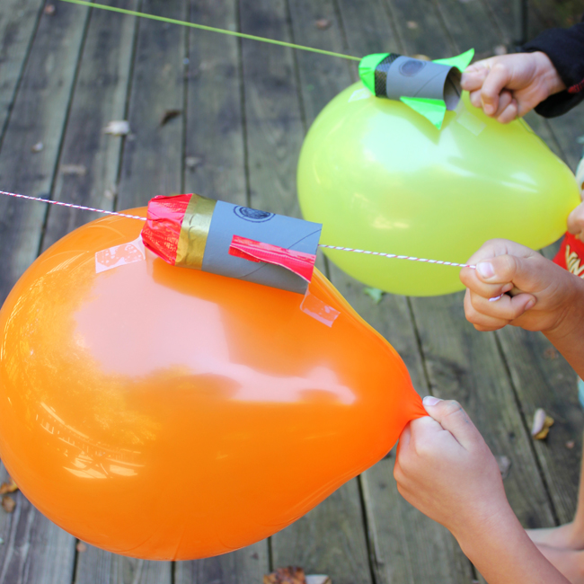
Remarkable Rockets
- Use junk modelling or craft items you have around your house to create your own rocket. Toilet roll tubes are a good starting point. You could have rocket races in the garden:
  - Tie a string up at an angle or use the washing line.
  - Blow up a balloon and sellotape it to your rocket. Hold the end of the balloon but do not tie it.
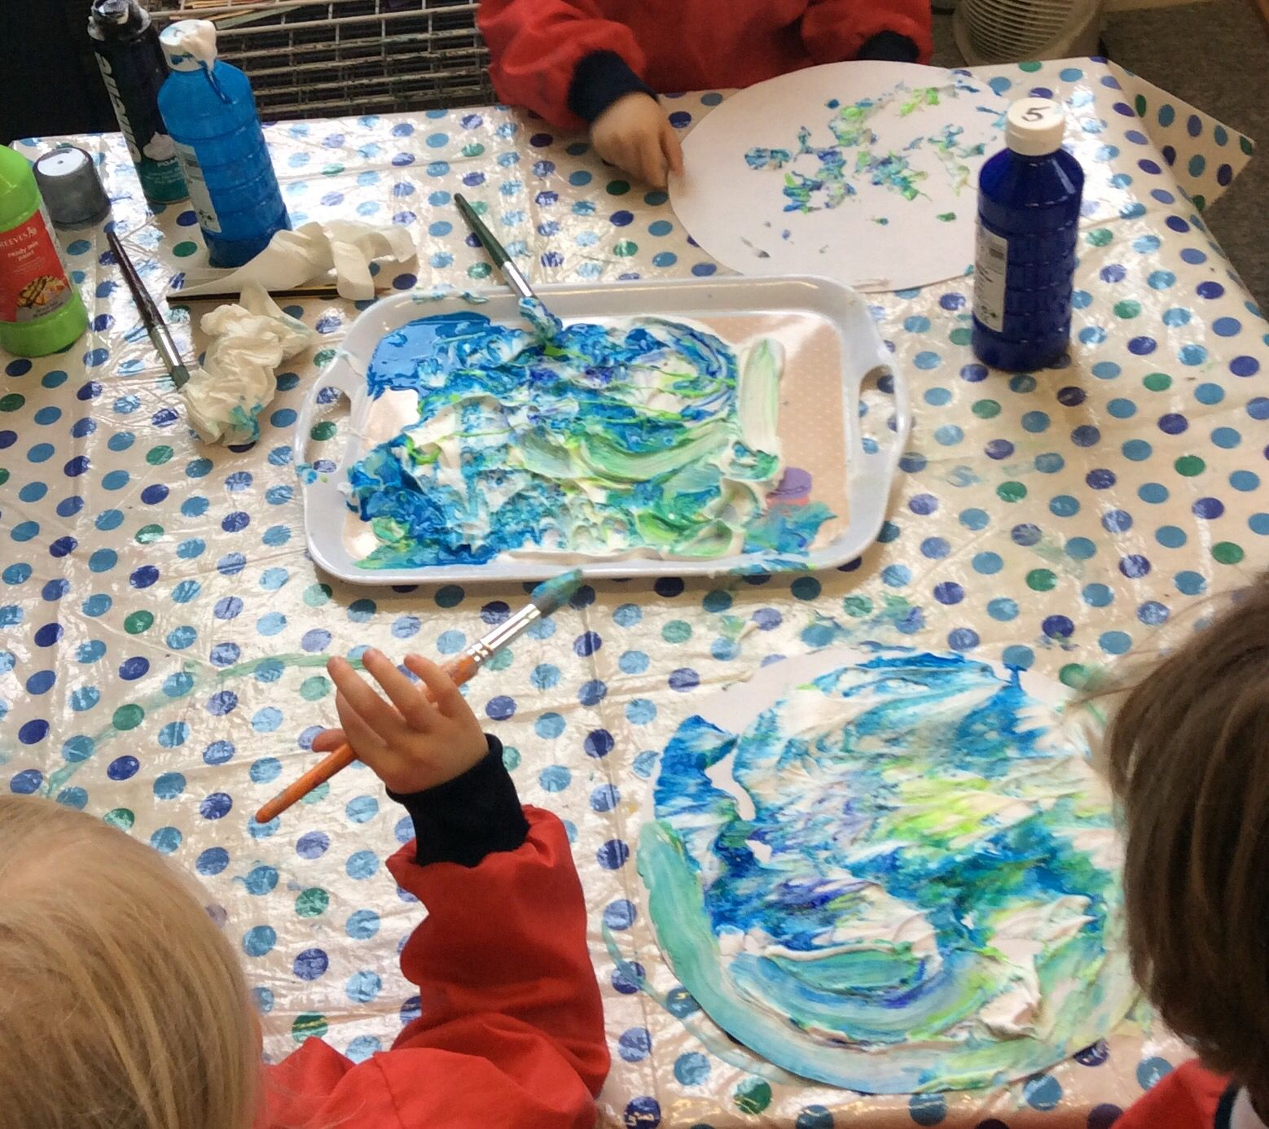
  - Let the balloon go and watch your rocket fly!

Make a Textured Planet
- Work with your child to create a replica of a planet. You could papier mache a balloon, or colour, paint or stick bits of materials on to the card to create textured effects. This shaving foam paint technique (see picture) creates a great textured finish when dry. Simply spray shaving foam onto a plate and drop in food colouring or poster paint.

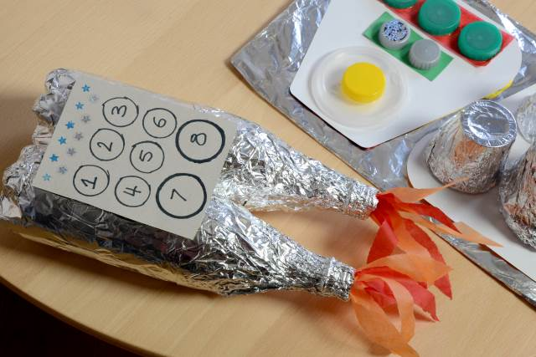
Explore Space Online
- Support your child in looking at the Earth from space using the Google Earth programme and identifying simple features such as water.
- Can you find your home? What does your child notice about the surrounding area?

Phone Home
- Create a space phone with your child using items from around the home. Get them to practise forming numerals correctly to create the buttons.
- Make a space phone book to support roleplay. Ask your child to draw a picture of a different alien on each page and write a phone number for them.

Have a Space Themed Party/Picnic
- Support your child to use tin foil to create shiny space suits for their teddies and dolls. They could have a space-themed teddy bear’s picnic afterwards where they share the biscuits in the next activity!
- Make yummy star biscuits to share at the picnic. Click here to find instructions on how to support your child in making simple star biscuits. They could share them at their space themed teddy bear’s picnic. Share photographs of your space themed picnic at #TheLearningProjects.

STEM Learning Opportunities #sciencefromhome
Mission X – Astro Agility Course
- Complete an agility course to improve movement skills, co-ordination, and speed. Record your speed and see if you can get faster with practise. See here.
- Sign up and access all of the Mission X resources here.
Additional learning resources parents may wish to engage with
White Rose Maths online maths lessons. Watch a lesson video and complete the worksheet (can be downloaded and completed digitally).
IXL Click on Maths, Reception. There are interactive games to play and guides for parents.
Talk for Writing Home-school Booklets are an excellent resource to support your child’s speaking and listening, reading and writing skills.
Classroom Secrets Learning Packs - These packs are split into different year groups and include activities linked to reading, writing, maths and practical ideas you can do around the home.
Twinkl - to access these resources click on the link.
The Learning Projects are based on the National Curriculum expectations for the key stage which your child is in. It may be that your child finds the tasks set within the Learning Project for their year group too simple. If this is the case, then we suggest that your child accesses the Learning Projects which are set for the key stage above (Elm Class). Equally, if the projects are too challenging, then we advise that your child accesses the projects for the key stage below (Saplings).
If your child requires more of a challenge, or you believe that there are some gaps in their learning then Century Tech is a fantastic resource that is currently free for home learning. The app is designed to address gaps and misconceptions, provide challenge and enables children to retain new knowledge. It uses artificial intelligence to tailor the learning to your child’s needs.
P4C (Philosophy 4 Children)
I have attached some ideas, on the school website, to get your children thinking out the ‘bigger questions!’ These sheets do not need to be printed and written out, they can just be an informal conversation that you have as a family to share ideas and opinions. Also please don’t feel you need to buy the books if you can’t find them around the house, they maybe available online

#TheLearningProjects
in collaboration with


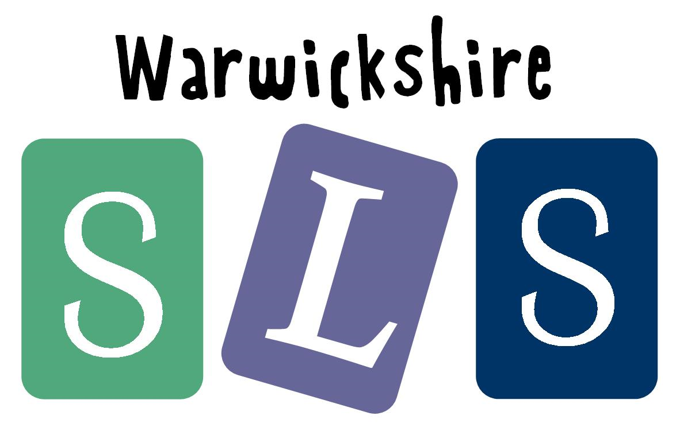
www.robinhoodMAT.co.uk

