W/C 1.06.2020: Learning Project - Around the World
Age Range: Ash
Physical Development
Gross Motor  - 9.00 am Joe Wicks  - Cosmic Yoga  - Daily mile and/or set up an obstacle course and time yourself.  - Give GoNoodle a try for fun movements and mindfulness | Fine Motor  Handwriting letters to practise:  (Around)  c- Curl around the caterpillar  - Around the apple and down the leaf  o- All around the orange  d- Around the dinosaurs bottom, up his tall neck and down to his feet  g- Around the girls face, down her hair, give her a curl
Weekly Reading Tasks | Weekly Phonics Tasks
Monday- Listen to stories from around the world - including: Handa's Surprise, The Tiger’s Child and If The World Were a Village. | Monday- Daily phonics - Practice the sounds your child is working on the Ruth Miskin’s website at 10am- set 2 sounds  NB. If you feel your child is secure in all set 2 sounds, you may wish to start set 3 sounds at 10.30
Tuesday- Choose one of the above stories to share again. Ask your child to retell the story in their own words once they are familiar. | Tuesday- Play Odd and Bob here. Children sort real words and nonsense words by sounding out.
Wednesday- Follow the story All Are Welcome Here with your child. Discuss how your child’ school makes everybody feel welcome. | Wednesday- Ask your child if they can think of a fruit or vegetable for each letter of the alphabet i.e. a=apple, b=banana.
Thursday- Play memory games, ‘I went to the market, I bought… The next person repeats the above sentence remembering the items bought already and adding a new one to the list each time. Use fruits like in Handa’s Surprise. | Thursday- Splat the Letter- Write out the letters for the sounds your child has been practising on pieces of paper and spread out on the floor. Take it in turns to shout out a sound and both players have to try and splat the sound with their hand.
Friday- Your child can practice reading their red words. Look at newspapers, magazines or leaflets together and circle these words with a felt tip pen or highlighter. | Friday- List countries from around the world e.g. Spain, Peru. Ask your child to identify the initial sound each country begins with. Can they identify other sounds e.g. S-p-ai-n?
Weekly Writing Tasks | Weekly Maths Tasks- Take Away
Monday- Encourage your child to look at the food in your kitchen and find out what countries some of it comes from. Search on a map for those countries. | Monday- Watch this video to support counting back from 10. CHALLENGE: Ask your child to start at 10 and take away 1. Repeat this until they get to zero. Do they recognise the amount is getting smaller?
Tuesday- After listening to the story Handa’s Surprise, ask your child to name and draw different fruits that they know. Label them using describing words. | Tuesday- Generate your own subtraction number stories. Use real life objects at home to show this e.g. ‘I have 4 bananas. I eat one. How many are left?
Wednesday- Ask your child to play in role as Handa from Handa’s Surprise. Ask them questions and they must answer as Handa e.g. ‘Handa, what is your favourite fruit?’ They might answer by saying ‘My favourite fruit is tangerines. I was very excited to find lots of them’. | Wednesday- Use a teddy and count backwards making deliberate mistakes. Can your child spot the mistakes? Mistakes can include omitted numbers, repeated numbers or a number in the wrong place. CHALLENGE: Ask your child to spot the mistake when the numbers are written down.
Thursday- Your child can draw a picture of a suitcase and all the things they might take on holiday. CHALLENGE: Ask your child to label the items. | Thursday- Look at these pictures of flags from around the world with your child. Can they spot any shapes in the flags and can they name them?
Friday- Ask your child to pretend they are on holiday. Get them to make a postcard to send to someone at home. Ask your child to draw a picture of what they are doing on holiday. Can they make a list of what they are doing? | Friday- Use the tens frames to subtract/take away numbers. CHALLENGE: Ask your child to write the accompanying number sentence e.g. 10-1= 9.  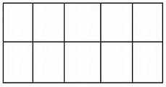

Learning Project - to be done throughout the week
The project this week aims to provide opportunities for your child to learn more about countries and cities around the world. Learning may focus on different cultures and traditions, famous landmarks, food and clothing.

Flags
- Look at flags from around the world. Discuss which are your child’s favourites and why? Ask your child to design and make their own flag using 2d shapes.

Food Tasting
- Find some different foods/fruits from around the world and taste each one. These might include: pizza (Italy), curry (India) and taco (Mexican) or the fruits from the story Handa's Surprise. Your child can create a chart putting a tick next to each food they like and a cross next to the foods they dislike over the course of the week.

Pleasing Puppets
- Make your own Handa’s Surprise character puppet. Click here for more ideas.

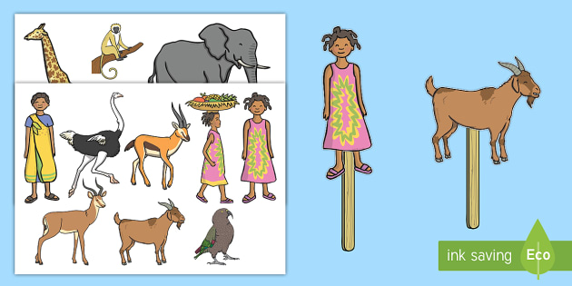
Toys from Around the World
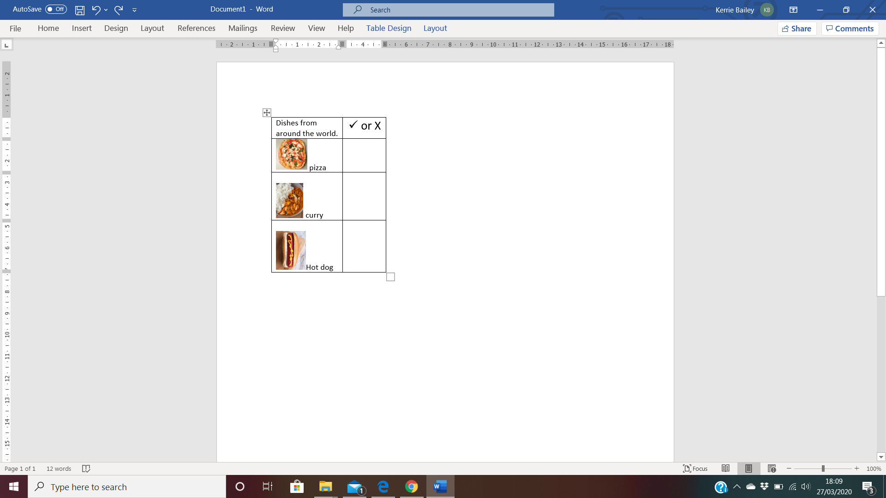
- Look at this photography project of children with their toys from around the world. Discuss how life is the same and how life is different in other countries. Can your child draw their favourite toy and write a sentence explaining why this is their favourite?

Where in the World?
- Discuss with your child where your family comes from in the world. If you have them available, show your child photographs of where you, or their grandparents, grew up. This might be similar to where they live now or completely different. Encourage your child to think about the differences between the places. Share your family photographs #TheLearningProjects so children can compare their own family origins with others.

STEM Learning Opportunities #sciencefromhome
Engineering Around the World – Bridges
- A bridge helps people move over obstacles like a river, a valley or a busy road. The world’s longest bridge is in China and is 164.8km long. It would take more than two days to walk the length of this bridge. Do you have any bridges near your home? What do they look like?
- Try building a bridge out of paper, Lego or any other building materials you might have at home. Your bridge needs to be big enough for a toy car or small toy to travel over.
Additional learning resources parents may wish to engage with
White Rose Maths online maths lessons. Watch a lesson video and complete the worksheet (can be downloaded and completed digitally).
Numbots. Your child can access this programme with their school login.
IXL Click on Maths, Reception. There are interactive games to play and guides for parents.
Talk for Writing Home-school Booklets are an excellent resource to support your child’s speaking and listening, reading and writing skills.
Classroom Secrets Learning Packs - These packs are split into different year groups and include activities linked to reading, writing, maths and practical ideas you can do around the home.
Twinkl - to access these resources click on the link.
The Learning Projects are based on the National Curriculum expectations for the key stage which your child is in. It may be that your child finds the tasks set within the Learning Project for their year group too simple. If this is the case, then we suggest that your child accesses the Learning Projects which are set for the key stage above (Elm Class). Equally, if the projects are too challenging, then we advise that your child accesses the projects for the key stage below (Saplings).
If your child requires more of a challenge, or you believe that there are some gaps in their learning then Century Tech is a fantastic resource that is currently free for home learning. The app is designed to address gaps and misconceptions, provide challenge and enables children to retain new knowledge. It uses artificial intelligence to tailor the learning to your child’s needs.
P4C (Philosophy 4 Children)
I have attached some ideas, on the school website, to get your children thinking out the ‘bigger questions!’ These sheets do not need to be printed and written out, they can just be an informal conversation that you have as a family to share ideas and opinions. Also please don’t feel you need to buy the books if you can’t find them around the house, they maybe available online
#TheLearningProjects
in collaboration with

