Wednesday 23rd March 2022

WALT: understand chronology by placing events and historical figures on a time line using dates.

Challenge

Can you add other periods of time to your timeline?

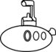

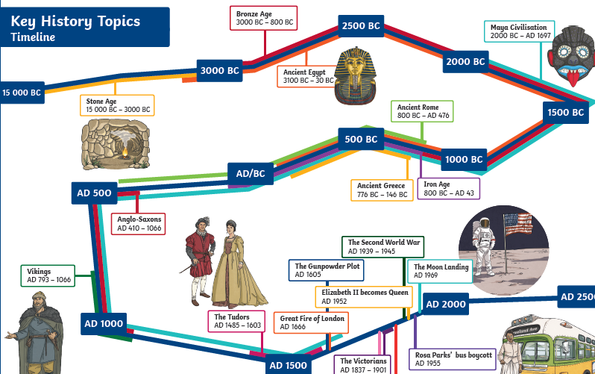

This picture is from a collection called ‘The Book of the Dead’. It

was discovered in Ancient Egyptian tombs and gives historians

lots of information about Egyptian beliefs and practices.

B

e

c

o

m

~~e~~

a

n

E

g

y

p

t

o

l

o

g

i

s

t

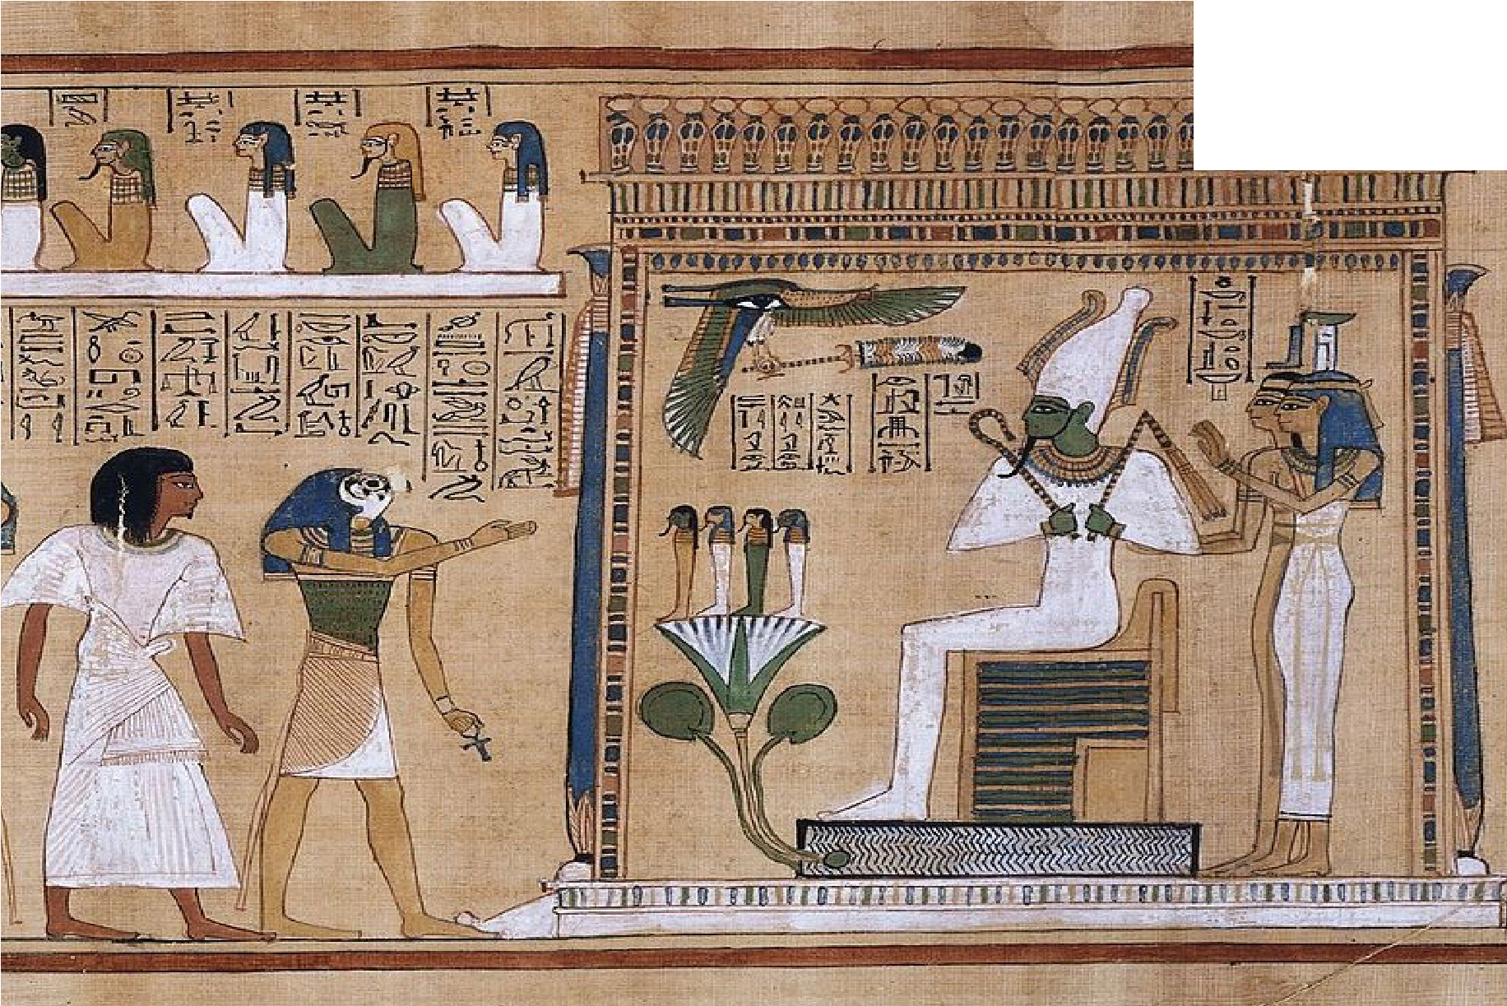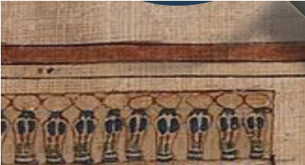

|  |
| --- |
| Circle these things when you find them:   * Picture messages (called hieroglyphics) * An animal headdress * A lotus flower * White robes * A feather * A falcon bird with one large eye |
| What else do you notice in the picture? |
| What questions does this picture give you about Ancient Egypt? |

Ancient Egypt Timeline

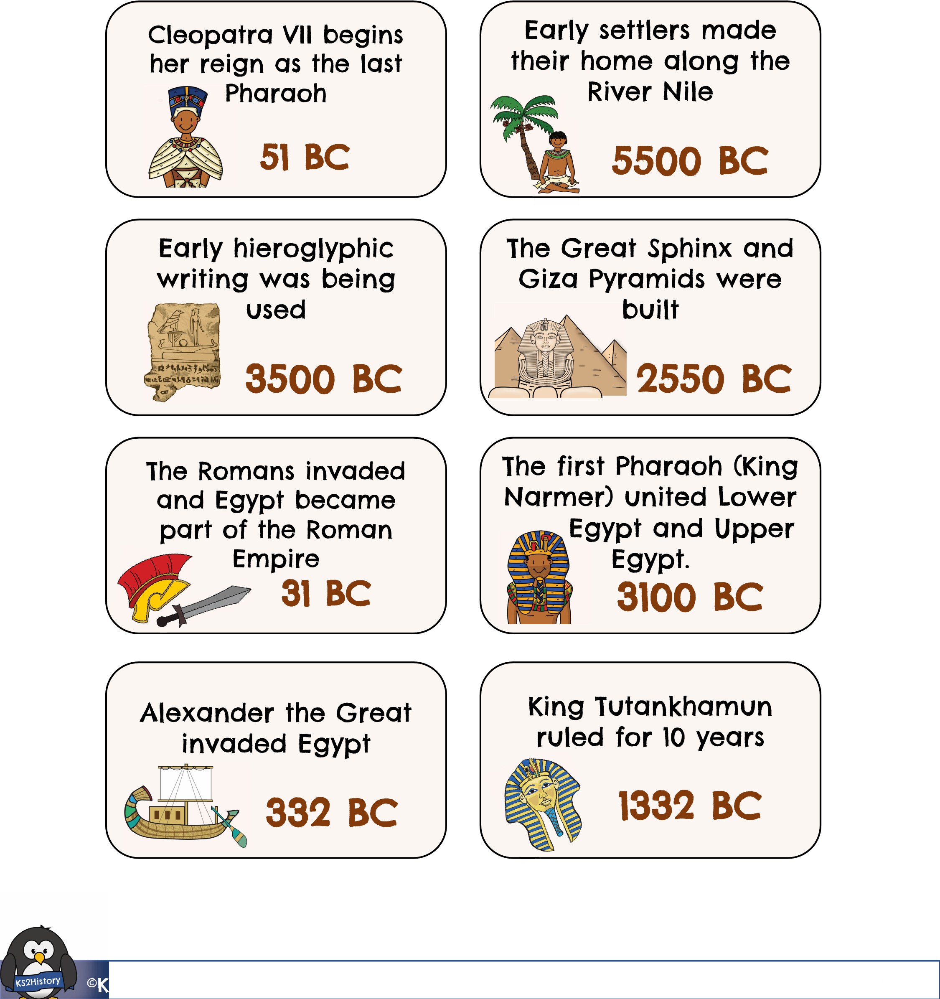Cut out the cards and place them to make a timeline in chronological order.