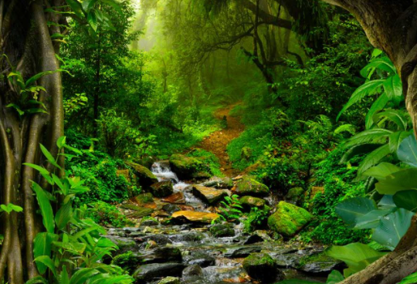

**Amazon Rainforest**

What do you notice is different?

What do you notice is the same?

Can you find this forest on a map?

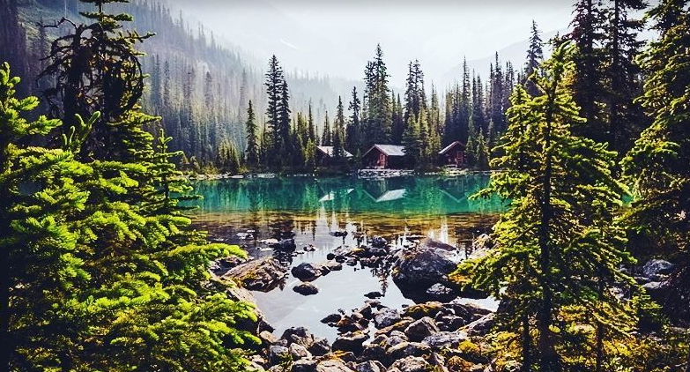

**Yoho National Park- Canada**

What do you notice is different?

What do you notice is the same?

Can you find this forest on a map?