Year 1 28th September 2017

For your home learning this week, please practise writing the words on the list below.

We will check what you have learnt in class on Tuesday.

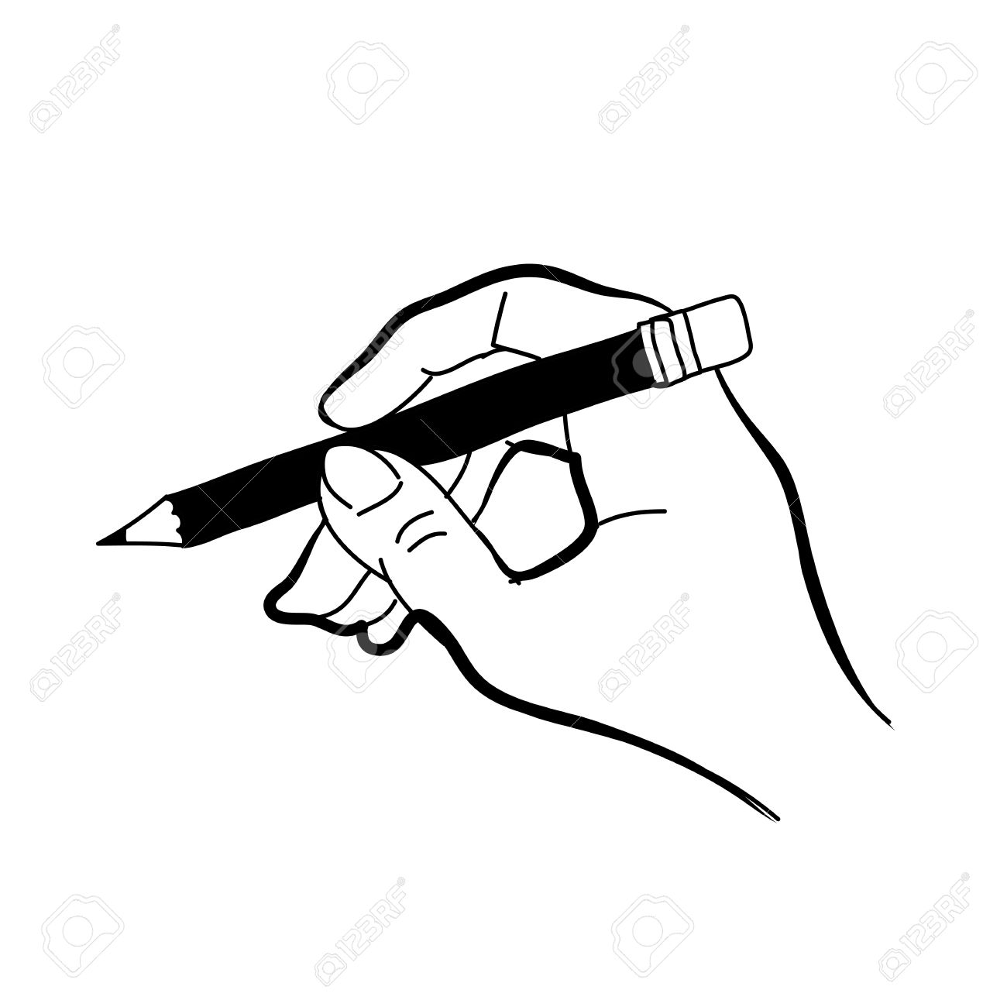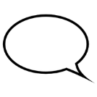Use the look, say, cover, write and check method to help you.

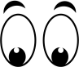hand-clipart-back_hand_clip_art_18634.jpg (428×200)

**Look Say Cover Write Check**

|  |  |  |  |
| --- | --- | --- | --- |
|  | Try 1 | Try 2 | Try 3 |
| the |  |  |  |
| do |  |  |  |
| to |  |  |  |
| was |  |  |  |
| is |  |  |  |

To practice what you have learnt, please can you write a sentence for each word?