Year 1 30th November 2017

For your home learning this week, please practise writing the words on the list below.

We will check what you have learnt in class on **Monday**.

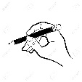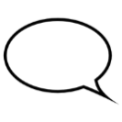Use the look, say, cover, write and check method to help you.

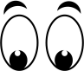hand-clipart-back_hand_clip_art_18634.jpg (428×200)

**Look Say Cover Write Check**

|  |  |  |  |
| --- | --- | --- | --- |
|  | Try 1 | Try 2 | Try 3 |
| **love** |  |  |  |
| **come** |  |  |  |
| **some** |  |  |  |
| **one** |  |  |  |
| **once** |  |  |  |

To practice what you have learnt, please can you write a sentence for each word?